Lesson Plan Template (Revised 2020)
Elementary Years
Name: | Daniel Mulhall

Grade | 4 | Topic | Careers Education 4 – Core Competencies SMART goals
Date | February 4, 2021 | Allotted Time | 45 minutes
STAGE 1: Desired Results

Cite sources used to develop this plan:
https://curriculum.gov.bc.ca/curriculum/career-education/4/core

https://firstpeoplesprinciplesoflearning.wordpress.com/

SMART Goal criteria

Rationale: How is this lesson relevant at this time with these students? Why is it important?
Starting on Monday, February 1 students have been sitting with, working with, competing with, and setting goals in a group. These groups are inspired by Harry Potter and are called Gryffindor, Slytherin, Hufflepuff, and Ravenclaw. Students in this class are very interested in Harry Potter, so I designed a careers education unit around their interest to increase engagement. By taking the 4 Hogwarts houses from the Harry Potter stories (Gryffindor, Slytherin, Hufflepuff, and Ravenclaw) I was able to associate core competencies with each group.

In the books/movies Gryffindors are associated with the characteristics of bravery, chivalry, daring, and courage. I took these characteristics and found core competencies that match these traits.
I connected Gryffindor to Social Awareness & Responsibility:
Building relationships,
Contributing to community and caring for the environment,
Resolving problems,
Valuing diversity.

In the books/movies Slytherins are associated with the characteristics of cunning, ambitious, determined, and leadership. I took these characteristics and found core competencies that match these traits.
I connected Slytherin to Critical Thinking & Reflective Thinking:
Analyzing and critiquing
Questioning and investigating
Designing and developing
Reflecting and assessing

In the books/movies Ravenclaws are associated with the characteristics of intelligence, creativity, originality, and wisdom. I took these characteristics and found core competencies that match these traits.
I connected Ravenclaw to Creative Thinking:
Creating and innovating
Generating and incubating
Evaluating and developing

In the books/movies Hufflepuffs are associated with the characteristics of loyalty, kindness, honesty, and friendship. I took these characteristics and found core competencies that match these traits.
I connected Hufflepuff to Personal Awareness & Responsibility
Self-advocating
Self-regulating
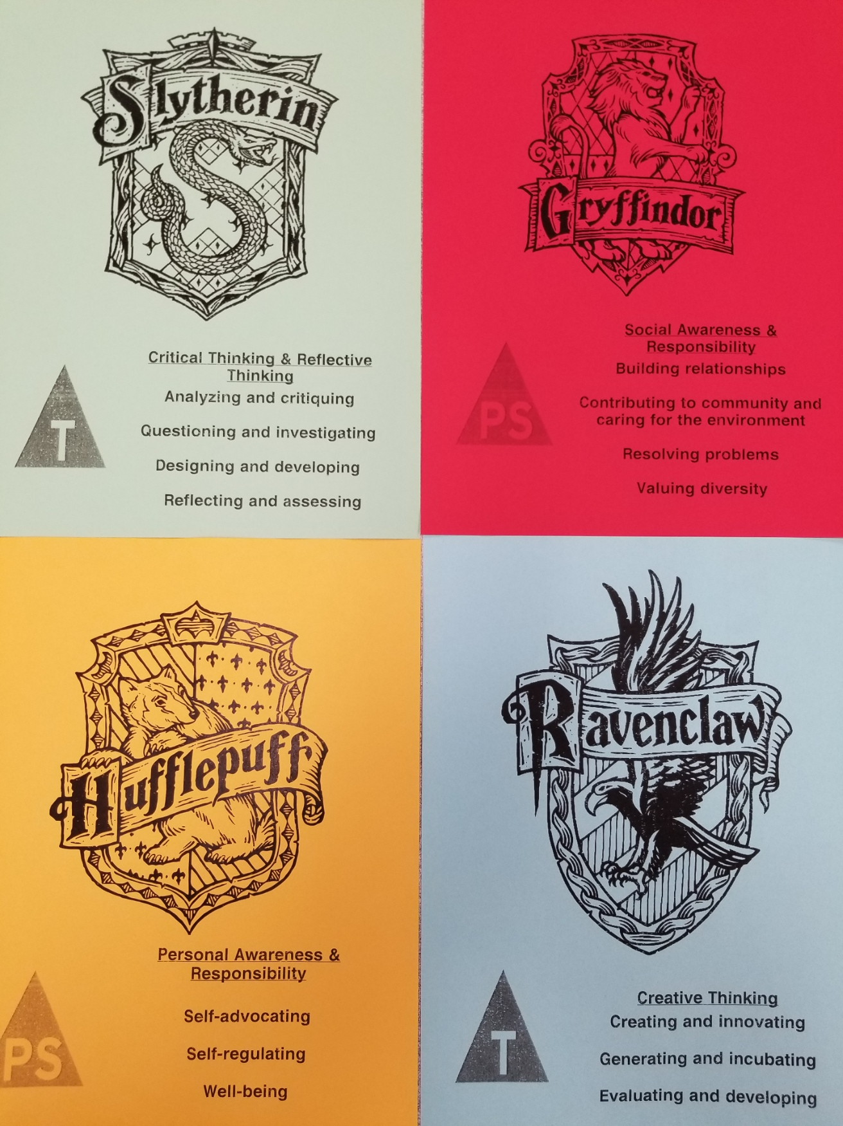
Well-being

Because of the Harry Potter theme, students have been incredibly engaged in this unit because it is something, they are interested in. Students were sorted into their new groups on Monday (I sorted based on a blending of strengths and skills, so each group would be a healthy blend). Each group got to pick a location in the room to create their “pod” of desks. Then each student was given a card to put on their desk (as seen in the picture). This card has the core competencies associated with their group so they can reflect and think about them all week. The core competencies were explained in detail to each group.

Students also completed a self-assessment of which core competencies they are strong in, and which ones they could work harder at.

All week, the core competencies have been revisited every morning, and the groups have been encouraged to brainstorm ways they can meet the core competencies associated with their group! In the previous lesson, students were asked to brainstorm a goal on a post it notes, I took these home and reviewed them, so I could provide feedback and advice for this lesson.

THIS LESSON will have students take everything we have discussed this week and set a SMART GOAL. The SMART goal criteria will be taught to the class and students will be required to set 2 SMART goals, based on their core competencies, for next week!

Core Competencies: https://curriculum.gov.bc.ca/competencies (refer to “profiles” for some ideas)
Which sub-core competencies will be the focus of this lesson? Briefly describe how and why:
Communication  - Communicating  - Collaborating | Thinking  - Creative Thinking  - Critical & Reflective Thinking | Personal and Social  - Personal Awareness & Responsibility  - Positive Personal & Cultural Identity  - Social Awareness & Responsibility
Although no group directly connects to the Communication core competencies, they have played a role in all aspects of this career unit. Student shave been required to communicate and collaborate with their groups all week (in the classroom and gym lessons).  In this lesson, students will be required to communicate with their group, brainstorm goals, and share ideas.  Students will need to collaborate and work together to blend the strengths of their team.  Students will also need to communicate their goals to the teacher through the SMART goals. | 2 of the groups (Slytherin and Ravenclaw) are directly linked to the thinking core competencies. These 2 groups will be required to set SMART goals based on how they can continue meeting these core competencies.  Students will be encouraged to | 2 of the groups (Gryffindor and Hufflepuff) are directly linked to the personal and social core competencies. These 2 groups will be required to set SMART goals based on how they can continue meeting these core competencies.

First Peoples Principles of Learning (FPPL):
How will Indigenous perspectives, knowledge & ways of knowing be acknowledged, honoured or integrated into this learning experience? (Jo Chrona’s Blog: https://firstpeoplesprinciplesoflearning.wordpress.com/)

FPPL to be included in this lesson: | How will the FPPL be embedded in lesson:
Learning ultimately supports the well-being of the self, the family, the community, the land, the spirits, and the ancestors | Students will continue to work on themselves by developing their core competencies. Every group has a different set of core competencies to set goals for.  (Gryffindors: work on inclusion and acceptance of all ideas.  Slytherins: work on problem solving and strategies.  Ravenclaws: work on thinking in new ways.  Hufflepuffs: work on self-reflecting.)  Students communicating and collaborating as a group will overall contribute to the classroom community. Each group will continue to build trust and relationship with one another as a community is built. This has already been seen in the blending of skills is working to the student’s advantage. Students are beginning to assist each other in different subject areas and utilizing their strengths and differences for the benefit of the group!

Curriculum Connections: https://curriculum.gov.bc.ca/ (Curriculum)
What Big Ideas (Understand),Curricular Competencies (Do), Content (Know) does this lesson develop?

Understand
Big Idea(s):

Exploring our strengths and abilities can help us identify our goals.

Family and community relationships can be a source of support and guidance when solving problems and making decisions.

Good learning and work habits contribute to short- and long-term personal and career success.

Essential or Guiding Question(s):

How can I set goals for my long-term success?
How can I develop and work on my core competencies?
How can I work with a group to support myself and others?
How can I set SMART goals for myself?
How can I self-assess my strengths?
How can I reflect on my progress?
How can I plan for my success?

Do
Curricular Competencies (Learning Standards):

Identify and appreciate their personal attributes, skills, interests, and accomplishments and their growth over time

Recognize the need for others who can support their learning and personal growth

Set realistic short- and longer-term learning goals, define a path, and monitor progress

Make connections between effective work habits and success

Appreciate the influence of peer relationships, family, and community on personal choices and goals

Know
Content (Learning Standards):

Personal Development
goal-setting strategies
problem-solving and decision-making strategies
emergent leadership skills

Connections to Community
cultural and social awareness

STAGE 2: Assessment Plan
FORMATIVE ASSESSMENT: (Assessment as Learning; Assessment for Learning)

Student post it notes goals were reviewed and assessed, as students build up their ability to set SMART goals. Students will learn as they discuss with their groups and new ideas will be explored.
Students will learn through discussion and collaboration with their groups and teacher.
Students will learn through sharing of ideas and brainstorming as a group.

SUMMATIVE ASSESSMENT: (Assessment of Learning)

The completed SMART goals sheet will be used to summative assess this lesson and this week overall unit! The successful completion of 2 SMART goals, associated with the core competencies, will demonstrate the students understanding. Goals will not be judged or criticized for their content, but rather on their following of the SMART goals criteria.
This summative piece of assessment will then be used to inform the direction of this unit and how the teacher can continue (assessment for planning).

The Learning Intention:  What will students learn in this lesson? (i.e. Learning Standards) | Students will reflect and demonstrate their understanding of the core competencies.  Students will set goals for themselves.  Students will self-assess their strengths and weaknesses.  Students will work together in groups using communication and collaborative skills.  Students will develop core competencies skills in a fun and engaging way.
Evidence of Learning:  How will students demonstrate their learning? What does it look like? | Students will set 2 SMART goals for themselves.  Students will work well and communicate with their group.  Students will reflect on their performance and recognize their unique skills/strengths.  Students will self-advocate for themselves and communicate what they need to work on.  Students will continue to group brainstorming and discussion.
Criteria:  What do students need to do to meet or achieve the learning intention? | Students need to self-assess and set goals for their own success.  Students need to work together and communicate with their group.  Students need to understand how they can meet their own core competencies.  Students need to actively participate.  Students need to be reflective and reflexive.

Planning for Diversity:
Learning Target: In what ways does the lesson meet the needs of diverse learners?
How will you plan for students who have learning/behaviour difficulties or require enrichment?
Students need to/must do  Work respectfully with their groups.  Set 2 SMART goals  Access/All | Students can do  Contribute to their group discussion and share ideas for goals.  Set 2 SMART goals based on their own experiences in school.  Most | Students could do/try to  Be leaders in their group, contribute ideas, facilitate discussion, and be models of respect.  Self-assess and self-reflect to set 2 SMART goals.  Few/Challenge

STAGE 3: Learning Plan

Resources, Material and Preparation: What resources, materials and preparation are required?
SMART Goals criteria
SMART Goals sheet

Post it note goals from yesterday’s lesson.
Goal planning work that has been done all week in this unit.
Cards for each group outlining the core competencies their goals should focus on.

Organizational/Management Strategies: (anything special to consider?)
After looking through the post it note goals and ‘scanning’ the students, I have a good idea of what students are struggling, and which students are extending, with their goal writing:
Luca wrote he wants to get better at dodgeball and Nicholas wrote about Beyblades. Meanwhile, extending and insightful goal setting was seen in: Eillie C, Landon, Brooklyn, Eleanor, Aiden, Liam, Raisa.
This allows me to pick leaders out of each group and ensure students are supporting each other.

Understanding that I will need to teach about SMART goals, so students know how to be successful in this unit. This may take time on my part, so making sure I utilize my lesson time wisely. Focusing on time and assisting students who need to focus on the SMART goals criteria.

Remembering to reflect on my own goals, and model to the students that even teacher work on themselves. Showing that setting goals is a part of life, even as a grown up. I will share my vulnerabilities about setting my own goals (doing well this practicum and becoming a good teacher).

Respecting privacy of student goals. Some students in the class have told me they do not want their goals shared with others because they are personal. I will ensure all goals stay private so students feel comfortable exploring themselves without fear of judgement. Also ensuring the class knows this is a judge free zone so they can work together as a community to support one another.

Some students may struggle with this unit. Considering how I can best support them (asking the EA to assist certain students, anticipating which students will require 1 on 1 assistance with this task).

Lesson Development:
Connect:  How will you introduce this lesson in a manner that engages students and activates their thinking? Activate or build background knowledge, capture interest, share learning intention. |  | Pacing
Teacher will  This lesson will occur after silent reading/music time. Yesterday during music time, the students were very high energy. There will be a need to cool down, refocus, and get students back into a working mindset (perhaps a calming breathing exercise or quick stretching will be utilized here, so students have that opportunity to clam their minds and bodies).  Recognize this will be a transition that will require support (after lunch, after a fun music time, afternoon, almost end of day before a long weekend).  Refocus the attention of the class using the techniques practiced during the week.  Ask students to return to their seats, clear off their desks, and take out a pencil.  Begin a conversation by telling students I read their goals from yesterday. Compliment and praise the students for their insightful and realistic goals! Develop a culture of acceptance and safety so students feel comfortable to really explore themselves through throughout this lesson.  Introduce SMART Goals to the students:  Explain that today we will be taking our goals from yesterday and developing them to be specific, measurable, attainable, relevant, and timely.  Go through each of the 5 criteria for their goals to be:  Specific: “What exactly do I want to accomplish?”  Measurable: “How will I know when I meet my goal?”  Attainable: “Is it possible to meet this goal with effort by my timeline?”  Relevant: “Is this goal worth working hard to accomplish? Does it help me with my long-term goals?”  Timely: “What is the deadline I have set to meet this goal?”  Provide examples of each of these 5 criteria.  SPEND SOME TIME WITH THESE CONCEPTS as this will set students up for success for this lesson. | Students will  Follow teacher guidance as cooldown/breathing exercises are used.  Focus on the teacher and follow prompts.  Clear desks return to seats and take out a pencil.  Listen as teacher goes over work completed last lesson. Reflect on how they think they did.  Listen and follow along as SMART goals are introduced and explained.  Ask questions or for clarification as required.  Follow along as the SMART goal criteria are explained.  Listen as examples are provided. | 15 mins

Process:  What steps and activities are you going to use to help students interact with new ideas, build understanding, acquire and practice knowledge, skillsand/or attitudes? In what ways have you built in guided practice? |  | Pacing
Teacher will  Ask students to discuss with their groups, ways to meet their goals (based on their group’s core competencies). This is something they have done in a few different formats this week. Students have already been asked to brainstorm as a group, and examples for each group’s core competencies has been provided by me.  Remind students to focus on each group member’s strengths and offer ideas/suggestions to their group members.  Advise they will have 10 minutes to collaborate and discuss.  Use these 10 minutes to check in with each group (all 4). Offer suggestions, ideas, contributions, reflections, and prompts to each group.  Assist students who require a bit mor direction and offer groups first examples.  Encourage students to strive for the SMART criteria (ex: “that is a great goal, but how can we measure it?” or “I really like that you recognize that area for growth, but how can we make that goal more specific so we can achieve it in a timely manner?”) This will help assist students who will require more guidance with this task.  Continue to check in with all students and groups. If multiple students ask the same question, regather the focus of the class and address the question to the class.  Refocus the attention of the class when needed and ensure students remain on task and noise level remains within guidelines. | Students will  Pay attention as directions and guidelines for lesson are explained by teacher.  Reflect on other careers/goal work completed this week. Consider how that work can assist us in today’s lesson.  Use the 10 minutes to communicate/collaborate with their groups (using the communication core competency guidelines). Share ideas, brainstorm, and assist group members as goals are discussed.  Each group has their own core competencies to reach. Discuss ways to reach those and consider working together to reach them.  Check in with teacher as required.  Ask questions if required.  Utilize time to work with group to support each other. | 15 mins

Transform:  How will students apply or practice their learning? Can they show or represent their learning in personalized ways? What are the choices for student task? |  | Pacing
Teacher will  Regather the focus of the class.  Advise students this is their time to write 2 SMART goals for themselves. They have had time to brainstorm and discuss with others, now is the time for them to reflect on their own goals by themselves.  Set the expectation that this time of the lesson should be silent, as students set their own personal goals without influence from others (this is to both increase productivity and ensure this remains a safe space for all self-reflection).  Hold up the SMART goal sheet:  “I will ________ by ________. I will reach my goal by __________”  Explain to the students that this is the sheet we will be using to set our goals.  Every student needs to set 2 SMART goals relating to their group’s core competencies.  Advise we will have 8 minutes to work on these and I will be circulating the room to assist. Remind students to raise their hands if they require assistance and I will check in with them to assist.  Advise the EA in the room which students will require direct support with this task (Nicholas and Luca).  Hand out a sheet to each student.  Set the time and tell students to begin.  Check in with each student as they raise their hands. Offer support, offer suggestions, and work with them. I have built up enough of a relationship with them, that I can offer suggestions (ex: Brooklyn you are so fast with your math, but since your group’s core competencies center around “thinking” maybe we could find ways to assist others and share your thinking?” Use this style of conversation to lead students to creating their own goals, without providing them with examples they can copy down.  Encourage and support students as needed.  Provide reminders of time remaining. | Students will  Focus on the teacher.  Listen as the criteria and learning intentions for this lesson are explained.  Consider 2 goals they can set for themselves that follow the SMART guidelines.  Think about how the expectations of this lesson can be met. Think about how they can make good choices.  Follow along as the guidelines and expectations are explained.  Take a sheet from the teacher,  Use the 8 minutes provided to self-reflect and set personal goals (relating to core competencies associated with their groups).  Check in with teacher and ask questions as needed.  Listen to reminders of time. | 10 mins

Closure:  How will you solidify the learning that has taken place and deepen the learning process?  Refer back to the learning intention, connect to next learning. |  | Pacing
Teacher will  When the time is up, advise students I will come around and collect their goal sheets.  (We typically have students tasked with picking up work, but because so many students expressed privacy concerns, I will pick them up so everyone feels comfortable).  As I am picking the sheets up, I will ask the class to put their heads on their desks and close their eyes. I will ask all students to show with their thumbs how they feel this went (thumbs up for great, thumbs sideways for ok, and thumbs down for bad). I will scan the room and take a quick note of which students have their thumbs down. As I collect their sheets, I will mark them with a quick check mark. This will allow me to consider how the student self-reflected about their work and take this into consideration when assessing their goals! This will also provide me with insight into if the class requires more time with these concepts.  Collect all work and then ask students to raise their heads.  Thank everyone for their hard work and begin the transition to reading groups.  End the lesson with some positivity and congratulate everyone for working so hard on their own career driven success. | Students will  Put name on goal sheet.  Put head down on desk. Consider how they feel about their goals, communicate those feelings with their teacher using the thumbs signals.  Raise head.  Listen as the lesson is concluded.  Begin the transition into the next lesson. | 5 mins
ReflectionWhat was successful in this lesson? If taught again, what would you change to make this lesson even more successful and inclusive for diverse and exceptional students?

Lesson Planning Guide (adapted from Thompson Rivers University)
The lesson plan template is designed as a guide for students to use when planning lessons. The plan may be adapted to specific subject areas and modified as students gain experience or to suit their presentation style. The template is a basic outline that can be used directly as printed or expanded from the electronic version. It is important that the lesson plan be sufficiently clear and detailed so that another teacher could use the plan to teach the lesson.

Rationale: Why are you teaching this particular lesson at this time? One consideration is the context for the lesson (e.g. this introductory lesson determines what students know and want to know about the topic, this lesson relates to previous and future learning by . . .) Another consideration is student motivation (e.g. what are some reasons the learner might care about the content/concepts/ skills for future learning, careers, or interests?).

Curricular Connections:
The curriculum asks you to plan what the students will DO, what they will KNOW, and then what they will UNDERSTAND. Big ideas capture the “big picture” or general area of learning (e.g. interdependence of living things with the environment, stories are a source of creativity and joy) and will be what students come to UNDERSTAND. Curricular competencies are what students will DO in their learning activities (e.g. using comprehension strategies, sorting and classifying data, making ethical judgments) that are related to each discipline. The learning standards for content or concepts are a more specific consideration of what students will come to KNOW. Many of the standards are written in broad, general terms to allow flexibility. You can, using the intention of the standard, make it clearer and more specific (e.g. learners will be able to describe the main idea in a paragraph or story, learners will be able to classify leaves based on properties they identify). The lesson should make a connection to both types of learning standards – curricular competencies as well as content. A reminder that the direction of new curriculum has identified core competencies of thinking, communication, and personal / social development as a foundation for all curricula.

Learning Intentions: How can you make clear and share with your learners what they are going to learn or have learned or accomplished? Statements like: “I can add two fractions” help frame their learning in positive student language.

Prerequisite Concepts and Skills: What concepts and skills are needed for students to be successful? This communication helps connect lessons together in a logical sequence by building/scaffolding new knowledge onto previous learning. For example, if students are going to be engaged in debate did you build or scaffold group work strategies, communication skills, expected etiquette, criteria beforehand?

Materials and Resources /References List all materials and resources that you and the students will need. What things do you need to do before the lesson begins? (e.g. prepare a word chart.) What things do the students need to do? (e.g.read a chapter in the novel.) Have you honoured the sources of ideas or resources? Disorganized materials can ruin a great lesson.

Differentiated Instruction (DI): (accommodations):How will you accommodate for diverse learners in your class? How will you allow for some variety in expression of learning? How can you modify the learning activities for success? How can you provide engaging extra challenges for those that are ready? How might you alter the learning environment if needed? Have you considered Aboriginal and cultural influences? IEP’s?

Assessment and Evaluation: Did the students learn what you taught them? What tools might you use for assessment (e.g. check list, rubric, anecdotal record). How will you provide formative feedback to students about their learning? The results of the assessment should be directly connected to what your students were able to write say or do related to the learning intentions and or curriculum. Strive for accuracy and build assessment into teaching and learning and not as an “add on” at the end.
Organizational/Management Strategies:Have you thought-out organizational management strategies to facilitate a proactive positive classroom environment? Some examples are: organizing for movement, distributing and collecting materials, grouping strategies, blended grade classroom logistics.

Aboriginal Connections / First Peoples Principles of Learning: Are there any connections to Aboriginal or other cultural knowledge, worldviews, or principles of learning?

Lesson Activities/Structure:
Connect: How will you get students interested/motivated/ hooked into learning? How will you connect this lesson to past and future lessons? How can you share the learning intentions in student friendly language? How will you provide a lesson overview?
Process: What sequence of activities will the student’s experience? What will you do? What will they do? Estimate how much time will each activity take (pacing)? What are grouping/materials strategies? There are many ways to describe the body (step by step, two columns dividing student and teacher activities, visual flow chart of activities and connections, others?)
Transform: How will students apply and personalize the learning? What will they do or create to show you that they have learned?
Closure: How will the lesson end? (e.g. connecting back to learning intentions, summarizing learning, sharing of accomplishments, connecting to next lessons). Google “40 ways to close a lesson.”

Reflections: Complete the reflections section as soon as possible after teaching the lesson. What went well? What revisions would you make to the lesson? Anything else?

