Lesson Plan Template (Revised 2020)
Elementary Years
Name: | Daniel Mulhall

Grade | 4 | Topic | Physical and Health Education 4 - Quidditch
Date | February 4, 2021 | Allotted Time | 50 minutes
STAGE 1: Desired Results

Cite sources used to develop this plan:
https://curriculum.gov.bc.ca/curriculum/physical-health-education/4/core

https://firstpeoplesprinciplesoflearning.wordpress.com/

Lesson inspired by the Harry Potter series by J.K. Rowling

Rationale: How is this lesson relevant at this time with these students? Why is it important?
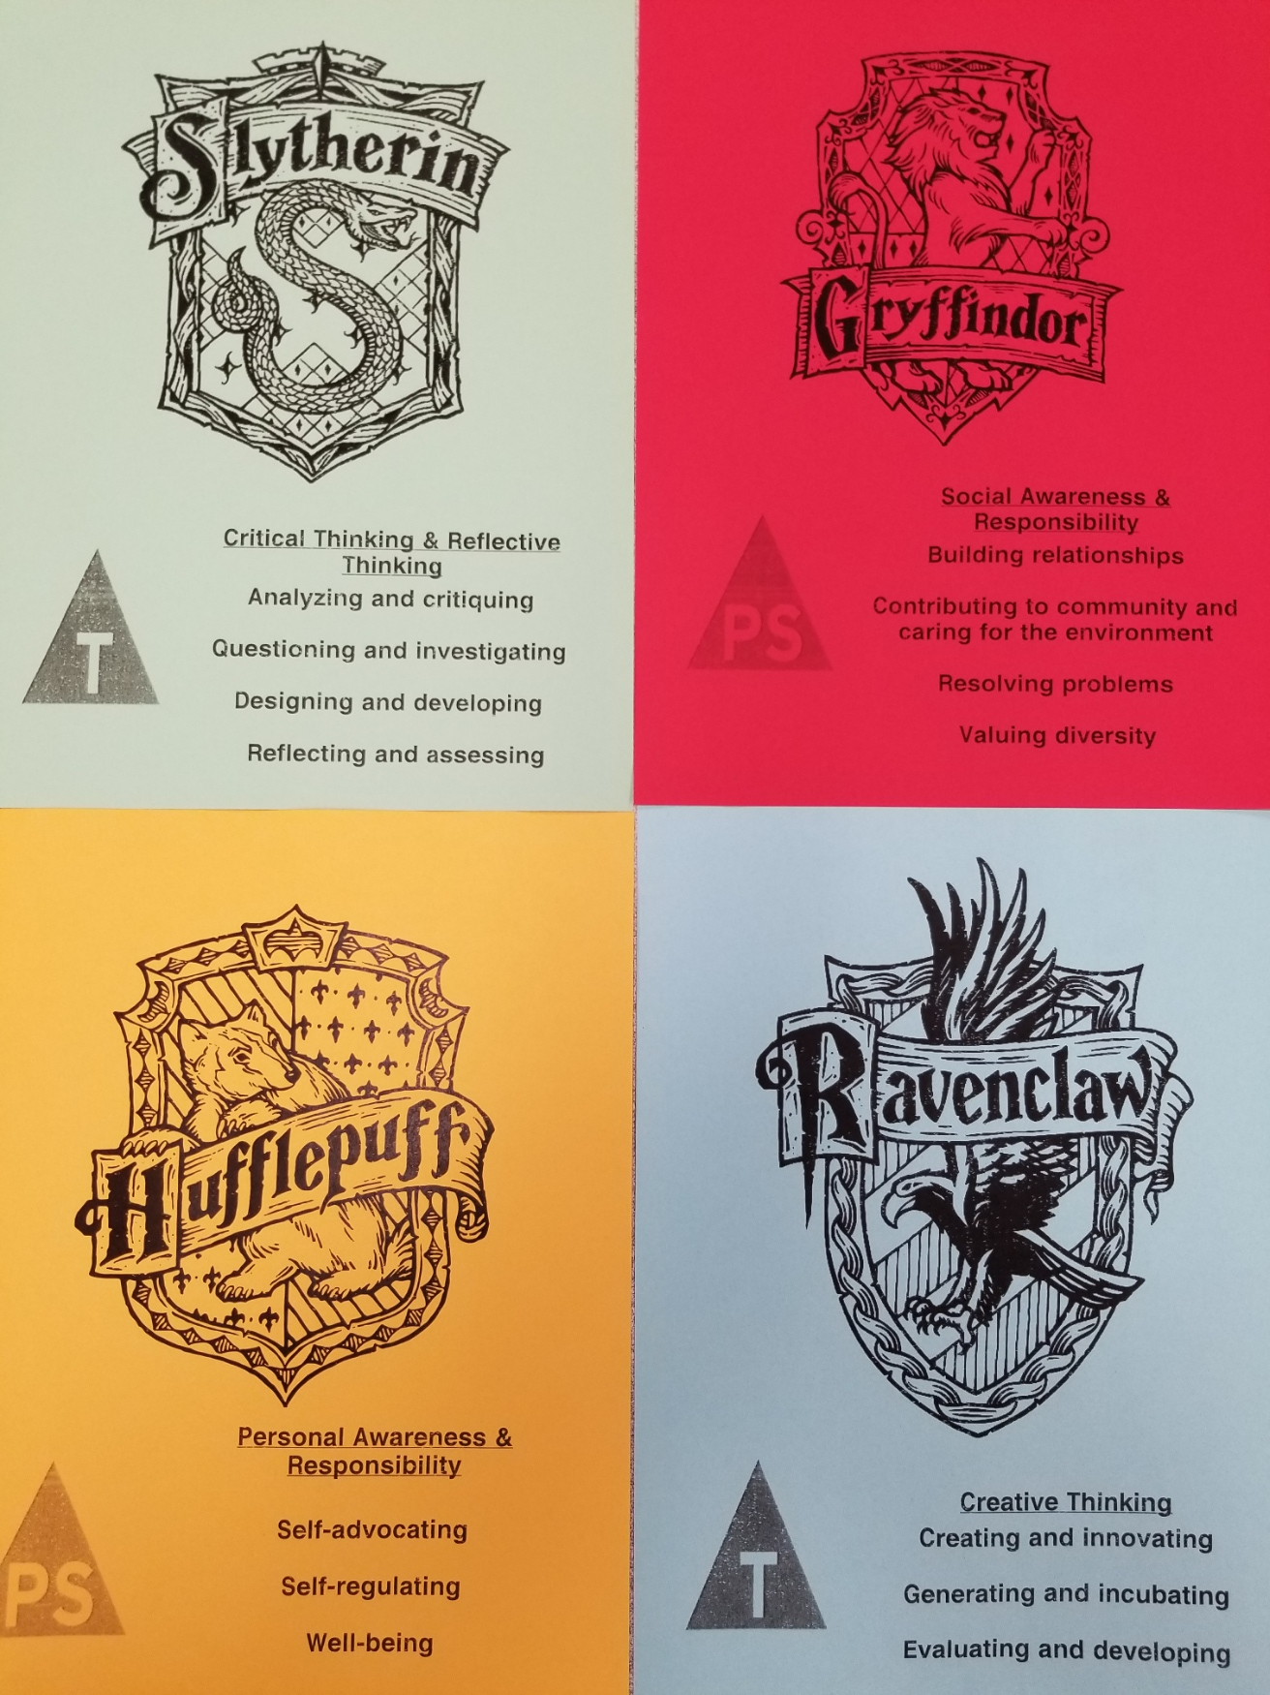
As part of our Career Education 4-unit plan, students have been divided into 4 groups. These groups are inspired by Harry Potter and are called Gryffindor, Slytherin, Hufflepuff, and Ravenclaw. As seen in the Career Education lesson plan, each grouping focuses on a different set of core competencies. All week long, students have sat together with their group, earning points and rewards with their groups, and set/established goal with their group. A strong focus on teamwork and a blending of personal strengths has been established in other lessons this week.

This physical education lesson will utilize these 4 groups and build upon their collaboration and communicating core competencies as they learn/play Quidditch.

This version of the game has been created by me. There are official ‘Quidditch’ games and leagues out there, but I created this game by myself, to best meet the needs and abilities of my classroom. Certain elements of the game “quidditch” have been removed with intention, such as the golden snitch.
Students were taught this game during Monday’s lesson. Students were asked to provide suggestions to the game at the end of Monday’s lesson which will be applied to the game this lesson (this gives the students a sense of ownership of the game, as some of the rules were codefined upon).

This game has been designed to teach students about strategy, teamwork, collaboration, and develop of the core competencies. Groups will be encouraged to utilize each member strengths to decide who will play in 3 available positions:
Keeper – essentially a goalkeeper, responsible for positioning the hoops and defending them.
Chasers – will pass the large softball to their other teammates, dodge balls, and strategize/communicate with their teammates.
Beater – lined up on the sides of the gym, armed with soft dodge balls to throw at opposing team members.
Each position uses a different skill (throwing, dodging/passing, and defending). Teams will have to decide which members will play each position (this is building strategy and reflection) among the students.
Students will have to play to their strengths while supporting their team.

Core Competencies: https://curriculum.gov.bc.ca/competencies (refer to “profiles” for some ideas)
Which sub-core competencies will be the focus of this lesson? Briefly describe how and why:
Communication  - Communicating  - Collaborating | Thinking  - Creative Thinking  - Critical & Reflective Thinking | Personal and Social  - Personal Awareness & Responsibility  - Positive Personal & Cultural Identity  - Social Awareness & Responsibility
Students will be required to communicate with their teammates during this game. Students will need to share positions, tactics, and comments with their teammates to win the game.  Students will need to collaborate and work together to blend the strengths of their team.  Students will need to decide with their team regarding who will play in each position. | Students will need to think in new ways, as elements of multiple games are combined. Students will need to plan and communicate their plans to pass the ball, while still thinking about ways to dodge other balls. This combination of tasks will require students to think both creatively and critically about their techniques. These techniques will need to be communicated with their teammates as well. | Students are playing on their teams, which have been an aspect of their classroom this week. Students will be required to demonstrate their social awareness and their responsibility to their team! Students will be assessed as a team and how well they blend their strengths, this will require personal reflection as student assess and advocate for where their talents lie.

First Peoples Principles of Learning (FPPL):
How will Indigenous perspectives, knowledge & ways of knowing be acknowledged, honoured or integrated into this learning experience? (Jo Chrona’s Blog: https://firstpeoplesprinciplesoflearning.wordpress.com/)

FPPL to be included in this lesson: | How will the FPPL be embedded in lesson:
Learning ultimately supports the well-being of the self, the family, the community, the land, the spirits, and the ancestors | This lesson encourages physical health which supports the student’s well-being.  Students will continue to work on themselves by developing their core competencies. Every team has a different set of core competencies to work on this week, which can be worked on in this game.  (Gryffindors: work on inclusion and acceptance of all ideas.  Slytherins: work on problem solving and strategies.  Ravenclaws: work on thinking in new ways to play the game.  Hufflepuffs: work on self-reflecting on their physical being).  A strong focus on good sportsman ship will support the classroom community, as other teams are supported/encouraged and valued. Each group will continue to build trust and relationship with one another as a community is built.

Curriculum Connections: https://curriculum.gov.bc.ca/ (Curriculum)
What Big Ideas (Understand),Curricular Competencies (Do), Content (Know) does this lesson develop?

Understand
Big Idea(s):

Daily participation in physical activity at moderate to vigorous intensity levels benefits all aspects of our well-being.

Essential or Guiding Question(s):

How can I work as a team?
How can I share my strengths with my teammates?
How can I communicate with my teammates?
How can I demonstrate good sportsmanship to other teams?
How can I engage in new physical activity games?
How can I blend elements from other games (handball, dodgeball), into one game?
How can I reflect and assess my own contributions?
How can I work on my core competencies?

Do
Curricular Competencies (Learning Standards):

Physical literacy
Develop and apply a variety of fundamental movement skills in a variety of physical activities and environments
Apply a variety of movement concepts and strategies in different physical activities
Develop and demonstrate safety, fair play, and leadership in physical activities

Healthy and active living
Participate daily in physical activity at moderate to vigorous intensity levels

Know
Content (Learning Standards):

proper technique for fundamental movement skills, including non-locomotor, locomotor, and manipulative skills
movement concepts and strategies

ways to monitor physical exertion levels

how to participate in different types of physical activities, including individual and dual activities, rhythmic activities, and games

STAGE 2: Assessment Plan
FORMATIVE ASSESSMENT: (Assessment as Learning; Assessment for Learning)

Students will be assessed through observation.
Students will be assessed on their ability to adapt to this new game, participate, share ideas with teammates, try their hardest, exert themselves, and good sportsmanship.
Students will be directly observed to assess their participation and involvement.

SUMMATIVE ASSESSMENT: (Assessment of Learning)

Students will be asked to assess themselves at the end of the lesson, to reflect on how they performed at the expectations.

The Learning Intention:  What will students learn in this lesson? (i.e. Learning Standards) | Students will learn to work as a team (Communication)  Students will learn how to show good sportsmanship and respect for other classmates.  Students will practice a variety of physical skills (throwing, dodging, running, defending).  Students will continue to reflect and demonstrate their understanding of the core competencies associated with their group.
Evidence of Learning:  How will students demonstrate their learning? What does it look like? | Students will demonstrate good sportsmanship.  Students will perform well at the game, based on their individual skills levels.  Students will play the game, following the rules  Students will work well and communicate with their group.  Students will reflect on their performance.
Criteria:  What do students need to do to meet or achieve the learning intention? | Students need to listen and follow the rules/guidelines for the game.  Students need to try their hardest.  Students need to work with their teammates.  Students need to actively participate.  Students need to work together and communicate.

Planning for Diversity:
Learning Target: In what ways does the lesson meet the needs of diverse learners?
How will you plan for students who have learning/behaviour difficulties or require enrichment?
Students need to/must do  Try play the game of quidditch by following the rules.  Respect their other classmates.  Access/All | Students can do  Play the game to the best of their ability and try pushing themselves.  Demonstrate good sportsmanship by remaining respectful and cheering other teams on.  Most | Students could do/try to  Strategize and plan new ways of playing the game.  Try to be leaders and demonstrate a advanced ways to demonstrating good sportsmanship.  Few/Challenge

STAGE 3: Learning Plan

Resources, Material and Preparation: What resources, materials and preparation are required?
6 hula hoops
1 large doftball
20 small soft dodgeballs
Team colours
Whistle
Timer

Organizational/Management Strategies: (anything special to consider?)
Students need a warmup and cool down for this lesson (consider how I can best utilize my time for this).

This is still a new game for them, how can I remain open to suggestions for improvement from the students?

Certain students demonstrated competitiveness last lesson (such as Landon), watch them to ensure all rules are being followed.

Consider teams and how they will play each other (ensuring all teams get the same amount of play time).

Consider timing of lesson.

I considered Nicholas who may become over stimulated and shut down. I support/consider him in this game by ensuring there is is a role that he can be successful at without getting over stimulated (beater). This keeps the game inclusive for all students.

Lesson Development:
Connect:  How will you introduce this lesson in a manner that engages students and activates their thinking? Activate or build background knowledge, capture interest, share learning intention. |  | Pacing
Teacher will  Have students line up by the classroom door in their preassigned Careers groups.  Have the students sanitize their hands (as pers school COVID19 regulations).  Remind students of hallway behaviour expectations (quiet in the halls, quiet feet, no running, etc).  Remind students of the 4 laps we do every time we enter the gym as our warmup.  Lead students to the gym in a single file line.  Open the gym doors and provide reminders of 4 laps.  Wait until all students have entered the gym and close the door.  Proceed to jog/run with students and encourage others to push themselves (this is to build relationship and show that I also take steps to improve my physical health).  When laps are complete, remind students to line up on preassigned line up lines.  Ask how everyone is doing! Ask them to show me, with their thumbs, how they are feeling physically (thumbs up = good and ready to go, thumbs sideways = alright, thumbs down = tired and not ready). This lets me scan the class and their energy levels. This also allows students to practice self-reflection and advocate for their physical health.  Ask 3 students to share the game we learned last lesson (quidditch).  Have students explain the rules (step in and correct where needed).  Have students repeat the key rules/regulations of the game.  Last lesson, I asked for suggestions and feedback about my game, I will explain how I incorporated their feedback for today’s game.  Explain that we will play a few games for practice before starting our tournament! (students are excited for the tournament).  Ask the students if they are ready to play this game again (students will be excited).  Ask students to grab their team colour (red, blue, green, yellow) and grab a seat on the benches with their teammates. As students are doing this, I will utilize the time to put the hula hoops and balls in their positions.  Have the equipment ready to set up beforehand and ask a few students to assist with the setting up.  Advise that we will start with Hufflepuff vs Gryffindor. | Students will  Line up by door in preassigned careers groups.  Sanitize hands as per school’s regulations.  Consider they expectations for the hallway behaviour and how to meet those expectations.  Walk to the gym in a single file line behind the teacher.  Run 4 laps around the gym to the best of their ability.  When completed 4 laps, sit down in the preassigned line up lines and be ready to begin the lesson.  Consider how they are doing, show how they are doing with their thumbs. Reflect on themselves and communicate it to their teacher.  Share what we did last class and explain the rules.  Be excited, ready to participate, and ready to follow direction.  Grab team colours and take a seat on the bench in their teams.  Assist with set up if asked by teacher. | 10 mins

Process:  What steps and activities are you going to use to help students interact with new ideas, build understanding, acquire and practice knowledge, skillsand/or attitudes? In what ways have you built in guided practice? |  | Pacing
Teacher will  Direct the Gryffindor and Hufflepuff teams onto the court.  Remind the other students (who aren’t playing) that they will act as referees! This helps keep them focused and engaged on the games they are not playing it!  Also remind students who aren’t playing that I will be watching for good sportsman ship, which means I want to hear them encouraging their classmates and being respectful!  Have the 2 teams who are playing decide which players will play which position. This decision making is up to each team because it requires them to collaborate and make decisions based on skill levels. After they have decided, I will have the chaser’s line up, touching the goalie box, and the beaters on the sidelines with dodgeballs ready.  Quickly remind students of the rules:  1). No player except the keeper can be in the goalie box.  2). No smacking the ball out of other player’s hands.  3). No running with the ball, only passing allowed.  4). If hit by a dodgeball thrown by the beater, they must drop the ball and freeze in place for 3 seconds.  5). Beaters can not enter the court and can only aim the dodgeballs at the players holding the ball (no headshots).  Review rules so students are reminded of the expectations and guidelines for this game.  Start the 5-minute timer and tell the students to begin.  Observe the game as it progresses.  Remind the students of key rules as needed.  When a goal is scored, make an announcement, and mark it on the scoreboard.  Observe all players to ensure everyone is following the rules, participating, and having fun.  Stop the game when needed (this will be done with a whistle – students will be preloaded with instructions to stop and freeze in place if they hear the whistle).  If there is a disagreement over a goal, ask the students watching to make their referee decision (this decision is final).  Watch students play and offer assistance and techniques to consider.  When the 5-minute timer is up and announce the winner! Remind students to say “good game” to the opposing team.  Ask the Ravenclaws and Slytherins to get ready to play and review the rules for the players.  Remind the other students of their expectations on the sidelines (last class they had fun coming up with cheers and cheering on their other classmates -this is highly encouraged.  Allow the next game to continue as noted above.  Now that all teams have played one practice round, it is time for the tournament to begin. | Students will  Gryffindor and Hufflepuffs will go onto the court.  If not playing, remember role as referees and consider how best to accomplish this (where to sit on the court).  Prepare to demonstrate good sportsmanship while others are playing.  Communicate and work together as a team to decide which members will play which roles (this requires students to make decisions and strategize about their team).  Work together as a team to decide who will play each position and where each team member’s strengths lie.  Follow and listen as the rules of the game are reviewed.  Begin the game.  Follow the rules of the game.  Work as a team.  Participate and try their hardest.  Work together to communicate and play strategies (there is a lot to consider in this game as things happen fast and techniques can be developed and experimented with).  If the teacher blows the whistle, freeze on spot and prepare to listen.  Students on the sidelines will make referee decisions in the event of a disagreement.  When the timer goes off, listen to the winner, and tell the other team “good game”.  Switch teams on the court and repeat above notes. | 15 mins

Transform:  How will students apply or practice their learning? Can they show or represent their learning in personalized ways? What are the choices for student task? |  | Pacing
Teacher will  Have students gather around to hear how the tournament will work.  Draw the “4 team elimination bracket” on the board.  Explain to students’ which teams will play each other and how the winner will move on to play the other winning team.  The tournament will go:  1). Gryffindor vs Ravenclaw  2). Slytherin vs Hufflepuff  3). Winning teams from round 1 and 2  Ensure the class understand how this tournament will work and answer questions or review rules as needed.  Have the Gryffindor and Ravenclaw teams enter the court.  Allow the game to run the full 5 minutes, with the winning team being announced at the end.  Fill in the winning team on the board.  Have the Slytherin and Hufflepuff teams enter the court.  Allow the game to run the full 5 minutes, with the winning team being announced at the end.  Fill in the winning team on the board.  Allow the 2 winning teams to compete in the final game of the class.  Allow this game to run for the full 5 minutes.  Announce the winner of the tournament.  Ensure good sportsman ship is practiced by all students. Point out examples of students demonstrating this and remind students the importance of losing AND winning with dignity! This is an important lesson for this unit. | Students will  Gather around and listen as the tournament layout and structure is explained.  Ask questions if they are unsure of something.  Consider and reflect if they understand.  Sit with teams and prepare for the tournament.  Begin the game.  Follow the rules of the game.  Work as a team.  Participate and try their hardest.  Work together to communicate and play strategies (there is a lot to consider in this game as things happen fast and techniques can be developed and experimented with).  If sitting on the side, act as referees, make judgement calls, cheer on other teams, and be good spectators. | 20 mins

Closure:  How will you solidify the learning that has taken place and deepen the learning process?  Refer back to the learning intention, connect to next learning. |  | Pacing
Teacher will  Gather the attention of the class.  Ask for all balls to be returned to me at the bin (to be sanitized). Advise students that they cannot throw them into the bin but have to bring them over to me.  Ask for 2 students to gather the hula hoops and large softball.  As students are gathering the dodgeballs, ask the other students to get ready in own “cool down” zone.  Once all equipment is put away, ask the class to self-assess how they did today.  Remind students this is based on participation, teamwork skills, and effort (not personal fitness).  Ask students to demonstrate how they feel they did today with their thumbs up, thumbs down, or thumbs sideways gestures!  Thank every team for their good sportsman ship and end the lesson on a positive note!  Ask all students to find a clear space for the cool down.  Proceed through 3-5 very simple yoga poses with a strong focus on deep breathing.  This will help regulate students and calm them down after a very exciting, competition-based lesson.  After the yoga, in a calm voice, ask students to line up.  Remind students of hallway behaviour expectations.  Lead class back to the classroom. | Students will  Focus on the teacher.  Return the balls to the ball basket. Bring in hola hoops.  GO to the cool down zone.  Self-assess how they did today (did they try their hardest? Were they good sports? Did they try new things? Are they happy with how they feel?)  Show with thumbs how they are feeling (self-assess).  Find a personal space and follow along as the teacher goes through a few yoga poses, with a focus on breathing.  Line up.  Walk back to class following hallway etiquette. | 10 mins
ReflectionWhat was successful in this lesson? If taught again, what would you change to make this lesson even more successful and inclusive for diverse and exceptional students?

Lesson Planning Guide (adapted from Thompson Rivers University)
The lesson plan template is designed as a guide for students to use when planning lessons. The plan may be adapted to specific subject areas and modified as students gain experience or to suit their presentation style. The template is a basic outline that can be used directly as printed or expanded from the electronic version. It is important that the lesson plan be sufficiently clear and detailed so that another teacher could use the plan to teach the lesson.

Rationale: Why are you teaching this particular lesson at this time? One consideration is the context for the lesson (e.g. this introductory lesson determines what students know and want to know about the topic, this lesson relates to previous and future learning by . . .) Another consideration is student motivation (e.g. what are some reasons the learner might care about the content/concepts/ skills for future learning, careers, or interests?).

Curricular Connections:
The curriculum asks you to plan what the students will DO, what they will KNOW, and then what they will UNDERSTAND. Big ideas capture the “big picture” or general area of learning (e.g. interdependence of living things with the environment, stories are a source of creativity and joy) and will be what students come to UNDERSTAND. Curricular competencies are what students will DO in their learning activities (e.g. using comprehension strategies, sorting and classifying data, making ethical judgments) that are related to each discipline. The learning standards for content or concepts are a more specific consideration of what students will come to KNOW. Many of the standards are written in broad, general terms to allow flexibility. You can, using the intention of the standard, make it clearer and more specific (e.g. learners will be able to describe the main idea in a paragraph or story, learners will be able to classify leaves based on properties they identify). The lesson should make a connection to both types of learning standards – curricular competencies as well as content. A reminder that the direction of new curriculum has identified core competencies of thinking, communication, and personal / social development as a foundation for all curricula.

Learning Intentions: How can you make clear and share with your learners what they are going to learn or have learned or accomplished? Statements like: “I can add two fractions” help frame their learning in positive student language.

Prerequisite Concepts and Skills: What concepts and skills are needed for students to be successful? This communication helps connect lessons together in a logical sequence by building/scaffolding new knowledge onto previous learning. For example, if students are going to be engaged in debate did you build or scaffold group work strategies, communication skills, expected etiquette, criteria beforehand?

Materials and Resources /References List all materials and resources that you and the students will need. What things do you need to do before the lesson begins? (e.g. prepare a word chart.) What things do the students need to do? (e.g.read a chapter in the novel.) Have you honoured the sources of ideas or resources? Disorganized materials can ruin a great lesson.

Differentiated Instruction (DI): (accommodations):How will you accommodate for diverse learners in your class? How will you allow for some variety in expression of learning? How can you modify the learning activities for success? How can you provide engaging extra challenges for those that are ready? How might you alter the learning environment if needed? Have you considered Aboriginal and cultural influences? IEP’s?

Assessment and Evaluation: Did the students learn what you taught them? What tools might you use for assessment (e.g. check list, rubric, anecdotal record). How will you provide formative feedback to students about their learning? The results of the assessment should be directly connected to what your students were able to write say or do related to the learning intentions and or curriculum. Strive for accuracy and build assessment into teaching and learning and not as an “add on” at the end.
Organizational/Management Strategies:Have you thought-out organizational management strategies to facilitate a proactive positive classroom environment? Some examples are: organizing for movement, distributing and collecting materials, grouping strategies, blended grade classroom logistics.

Aboriginal Connections / First Peoples Principles of Learning: Are there any connections to Aboriginal or other cultural knowledge, worldviews, or principles of learning?

Lesson Activities/Structure:
Connect: How will you get students interested/motivated/ hooked into learning? How will you connect this lesson to past and future lessons? How can you share the learning intentions in student friendly language? How will you provide a lesson overview?
Process: What sequence of activities will the student’s experience? What will you do? What will they do? Estimate how much time will each activity take (pacing)? What are grouping/materials strategies? There are many ways to describe the body (step by step, two columns dividing student and teacher activities, visual flow chart of activities and connections, others?)
Transform: How will students apply and personalize the learning? What will they do or create to show you that they have learned?
Closure: How will the lesson end? (e.g. connecting back to learning intentions, summarizing learning, sharing of accomplishments, connecting to next lessons). Google “40 ways to close a lesson.”

Reflections: Complete the reflections section as soon as possible after teaching the lesson. What went well? What revisions would you make to the lesson? Anything else?

